PART A – Short Answers (2 × 10 = 20 Marks)
1. Define Machine Learning. Mention two engineering applications.
2. List the types of Machine Learning problems with one example each.
3. State Bayes’ theorem and explain its components.
4. Define conditional probability and write its mathematical expression.
5. What is hypothesis space in supervised learning?
6. Write the cost function of Linear Regression.
7. What is overfitting? Mention one remedy.
8. What is the sigmoid function used in Logistic Regression?
9. What is meant by regularization?
10. Differentiate between supervised and unsupervised learning with one example each. (CO2 – AP)
11. What is the role of linear algebra in machine learning? (CO1 – U)
12. Write the hypothesis function of linear regression. (CO3 – R)
13. What is cross-validation? Why is it needed? (CO3 – U)
14. Define discriminative and generative models. (CO2 – U)
15 . What is meant by Gradient Linear Models? (CO3 – U)

PART B – Analytical Questions (10 × 3 = 30 Marks)
11 (a) Explain the mathematical foundations required for Machine Learning with emphasis on Linear Algebra, Probability, and Vector Calculus.

11 (b) Differentiate between discriminative and generative models with suitable examples.

12 (a) Given the hypothesis hθ(x) = θ0 + θ1x, derive the Mean Squared Error cost function and explain how Least Squares minimizes it.

12 (b) Explain Logistic Regression for binary classification. Derive the sigmoid function and discuss decision boundary formation.

13 (a) Discuss underfitting and overfitting using bias–variance trade-off analysis.
13 (b) Explain Gradient Descent algorithm. Derive the parameter update rule and discuss the role of learning rate.

11. (a)
Explain the types of Machine Learning problems with suitable examples. Discuss their advantages and challenges. (CO2 – AP)
11. (b)
Discuss the mathematical foundations required for Machine Learning with emphasis on:
- Linear Algebra
- Probability Theory
- Vector Calculus
(CO1 – AP)

12. (a)
Given a dataset with feature vector x∈R^{n} derive the cost function for Linear Regression and explain the least squares solution.
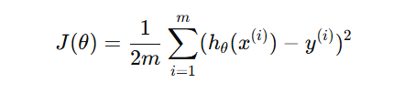Explain how overfitting can be handled. (CO3 – AN)
12. (b)
Explain Logistic Regression as a classification algorithm.
- Derive the sigmoid function
- Explain decision boundary
- Compare it with Linear Regression
(CO3 – AN)

13. (a)
Explain Bayesian Conditional Probability and Decision Theory in the context of Machine Learning. Illustrate with an example. (CO1 – AP)
13. (b)
Discuss the concept of Cross-Validation in detail. Compare Hold-Out method and k-Fold Cross Validation with suitable diagrams. (CO3 – AN)

14. (a)
Explain Lasso Regression. Derive the cost function including regularization term and discuss its impact on model complexity.
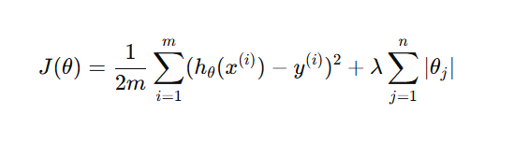
14. (b)
Explain Gradient Linear Models in detail. Discuss how gradient descent is used for parameter optimization.
Derive the update rule:
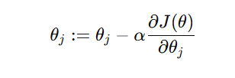

15. (a)
Explain Underfitting and Overfitting using bias–variance trade-off analysis. Illustrate with suitable graphs. (CO3 – AN)
15. (b)
Discuss Information Theory concepts used in Machine Learning such as Entropy and Mutual Information.
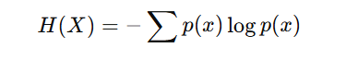 (CO1 – AP)

16 . A housing price prediction model is trained using Linear Regression. After training, the model performs well on training data but poorly on test data.
(a) Identify the problem and justify your answer.
(b) Suggest at least three techniques to improve model generalization.
(c) Explain mathematically how regularization improves the model.
(d) Describe how cross-validation would help in selecting model parameters.

